Jenkins-assignment 8:
You have Remote Repo which has 3 branches (Q1, Q2, Q3) contains index.html each, create 3 Freestyle jobs on Jenkins Master which will deploy Q1 branch on Slave-1, Q2 on Slave-2, Q3 on Slave-3
Remote Repo with 3 Branches each contains index.html
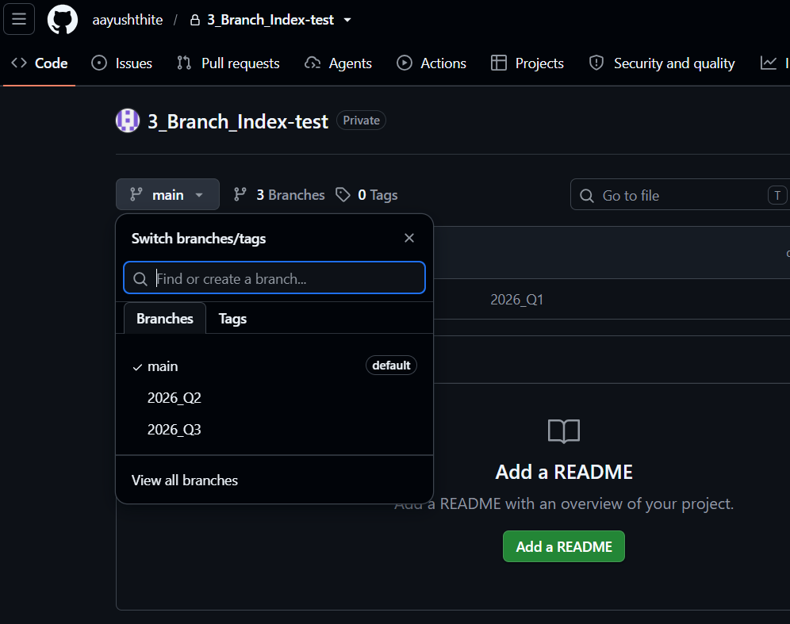
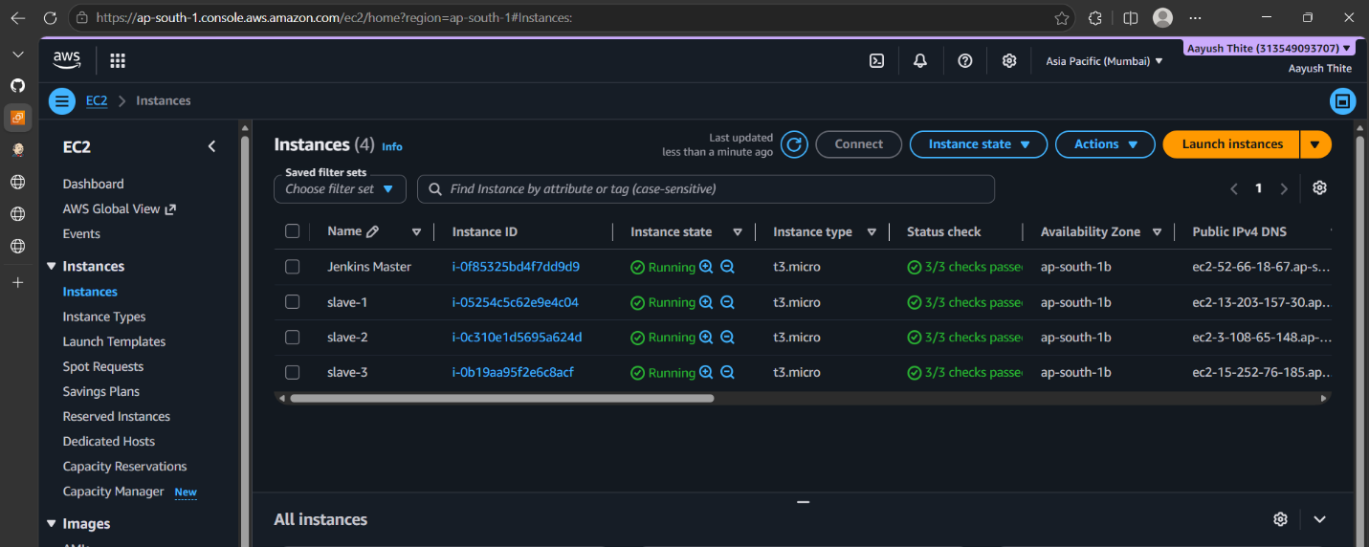
Configured and established Jenkins master with 3 slaves connection
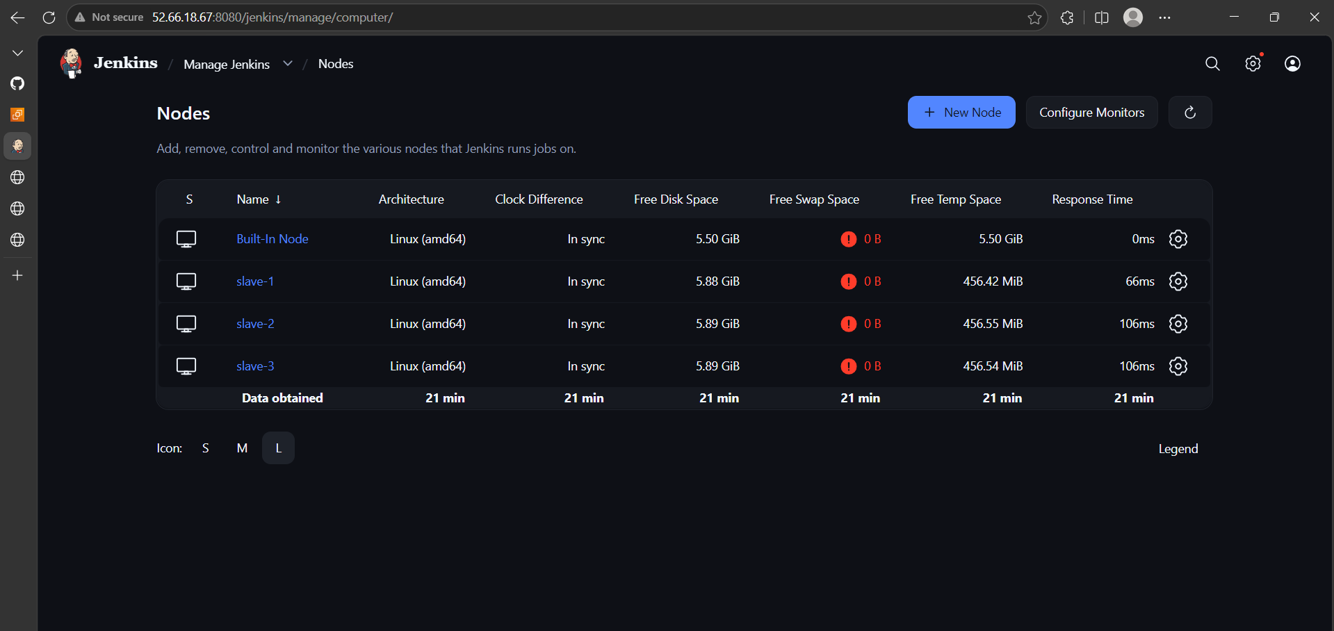
Configured slave-1-job
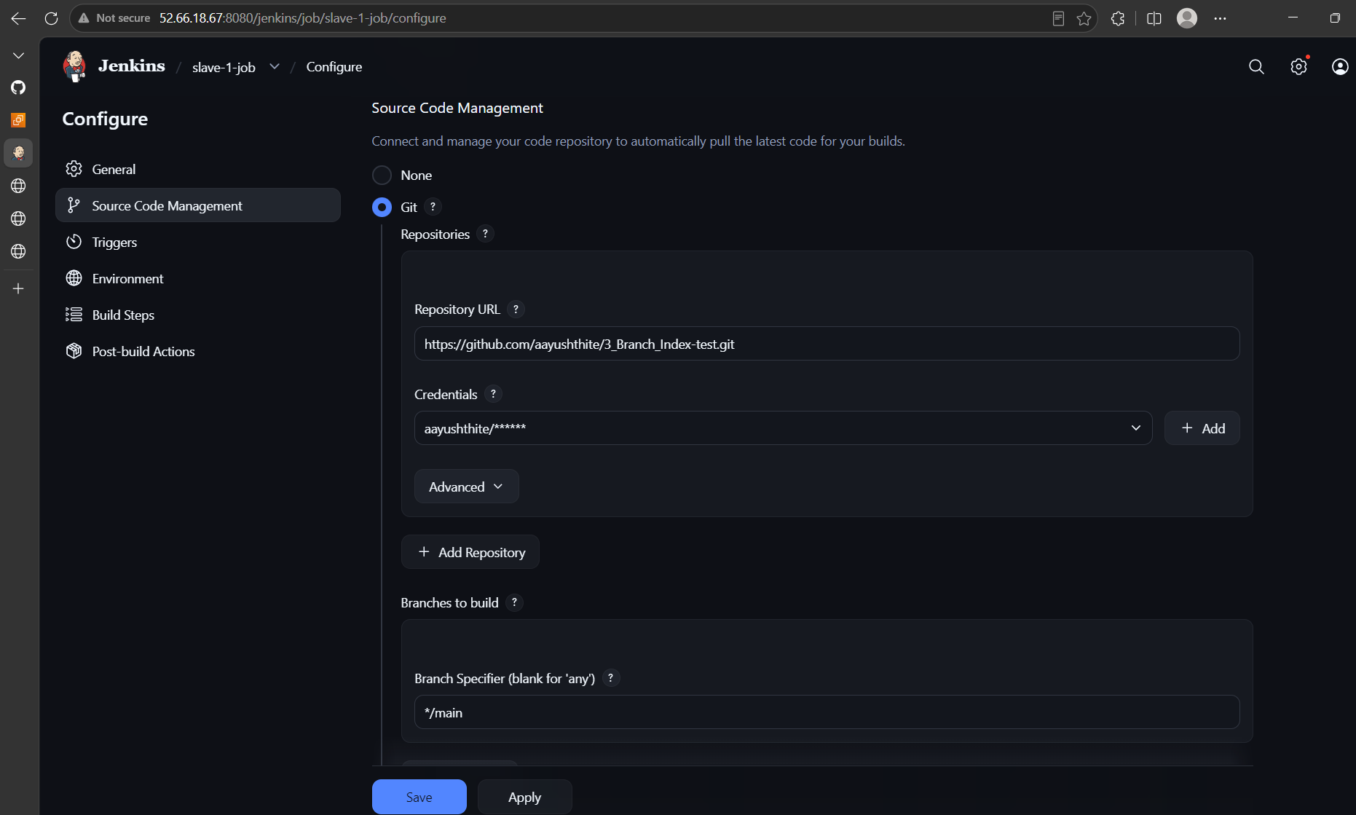
Started httpd service and deploy index.html from Q1-Main Branch
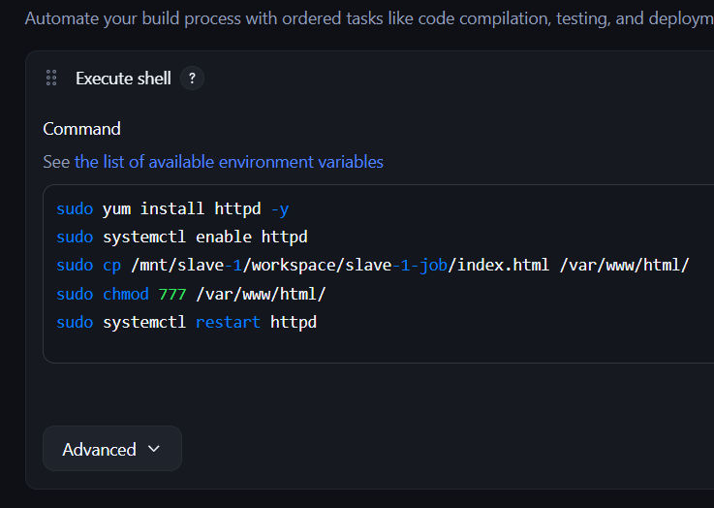
Slave-1-job Build Successful

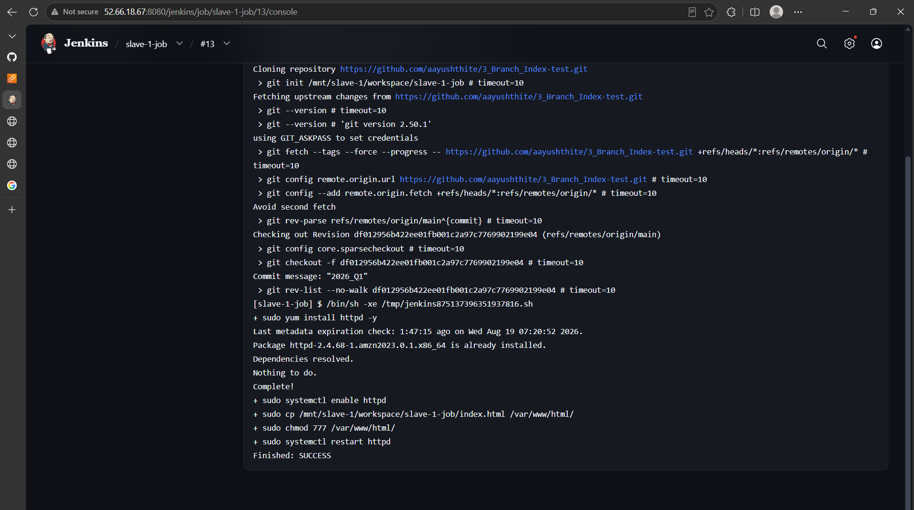
Q1 index accessible from browser
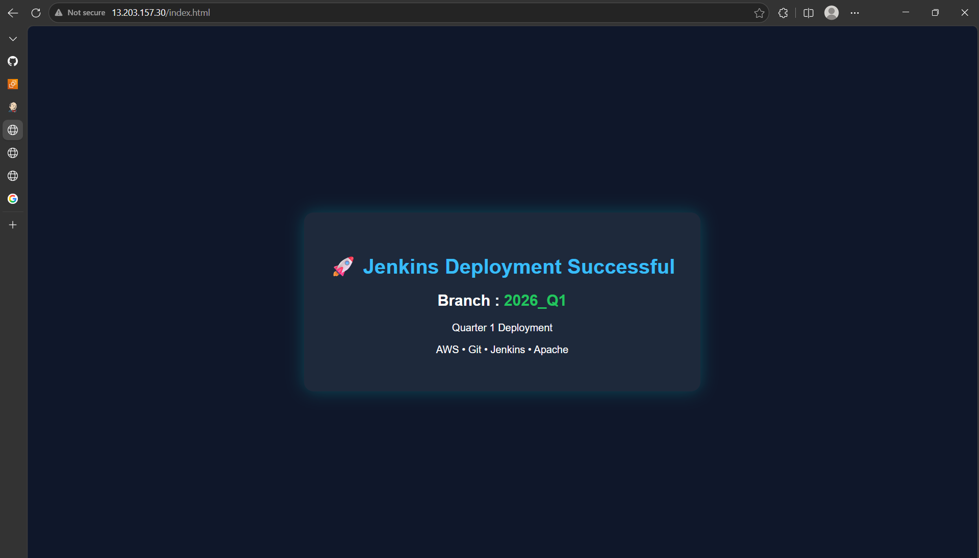

Slave-2-job
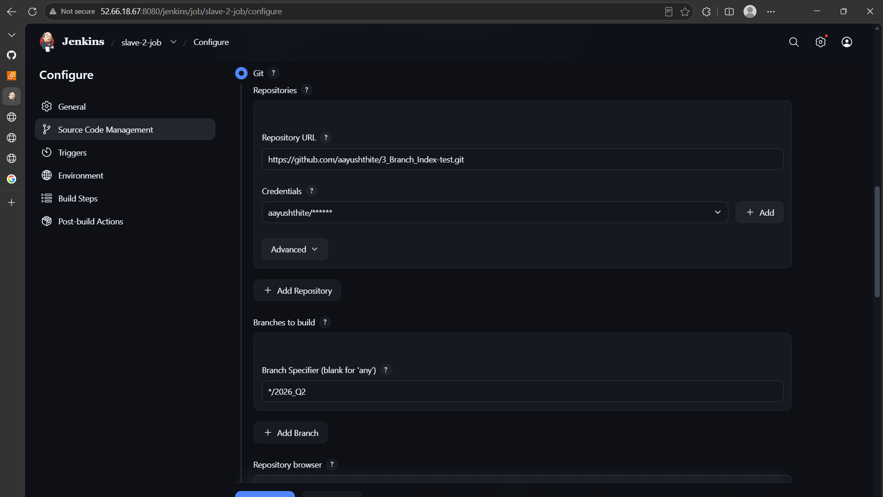
Started service httpd and deploy 2026_Q2 Branch on Slave-2
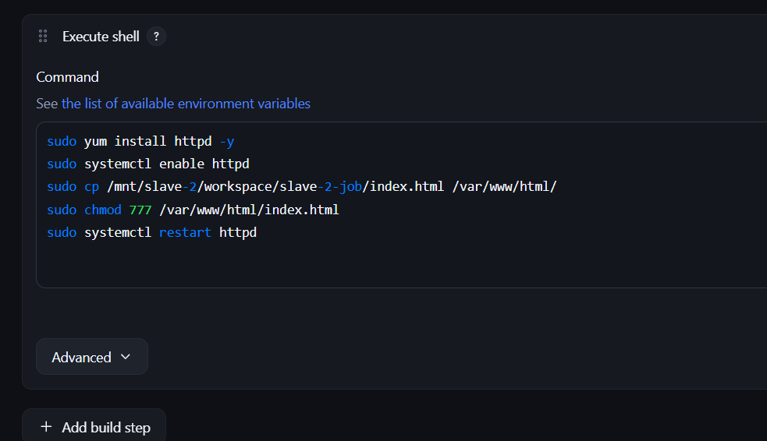

Slave-2-job build successful
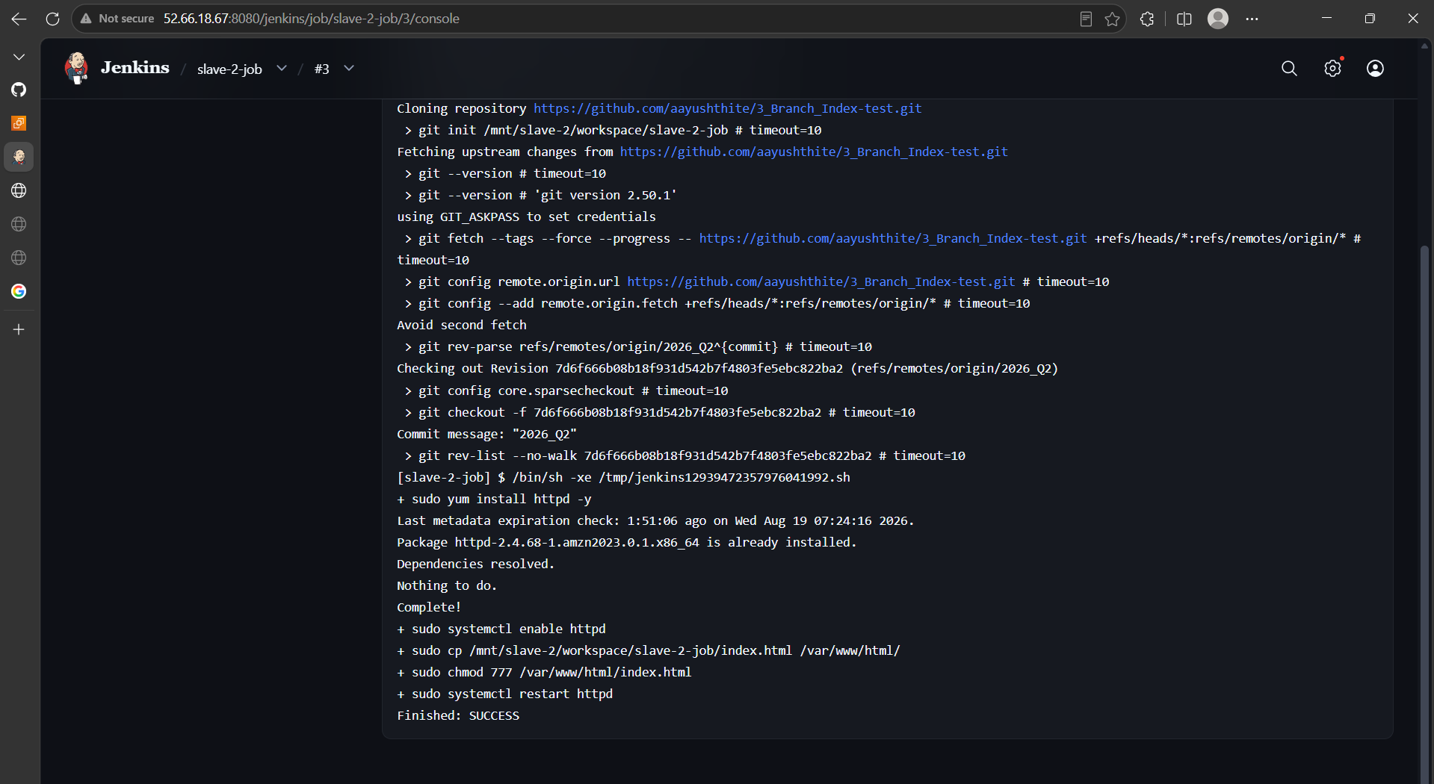

Q2 Branch index.html accessible from browser
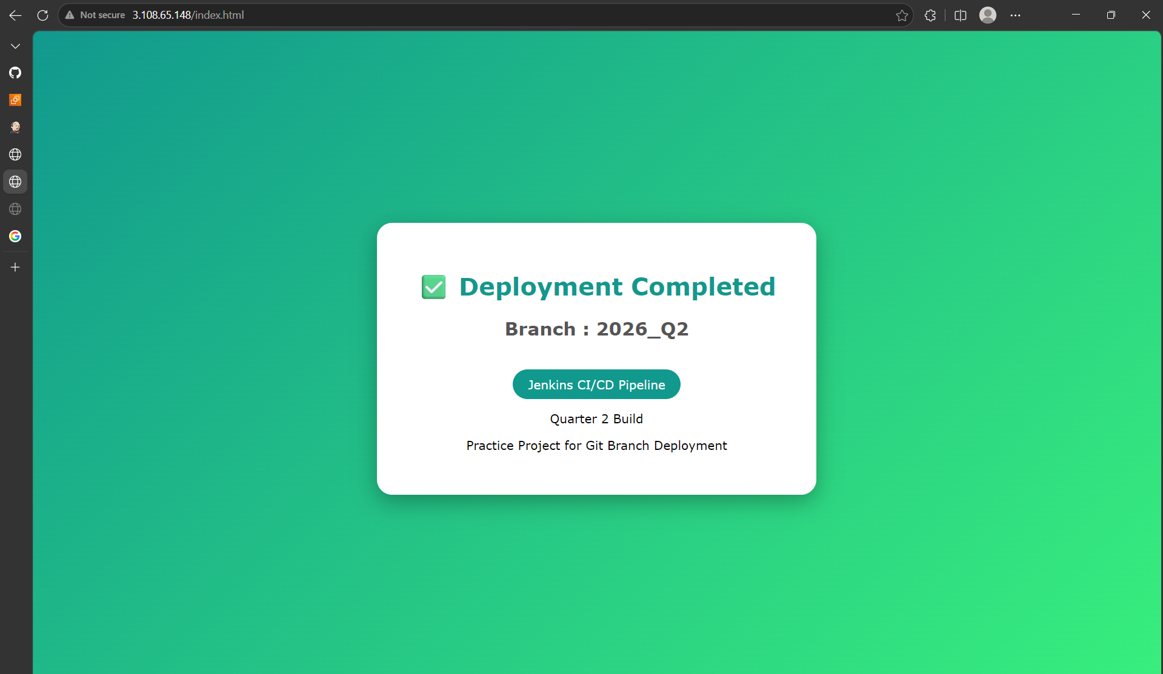
Slave-3-job
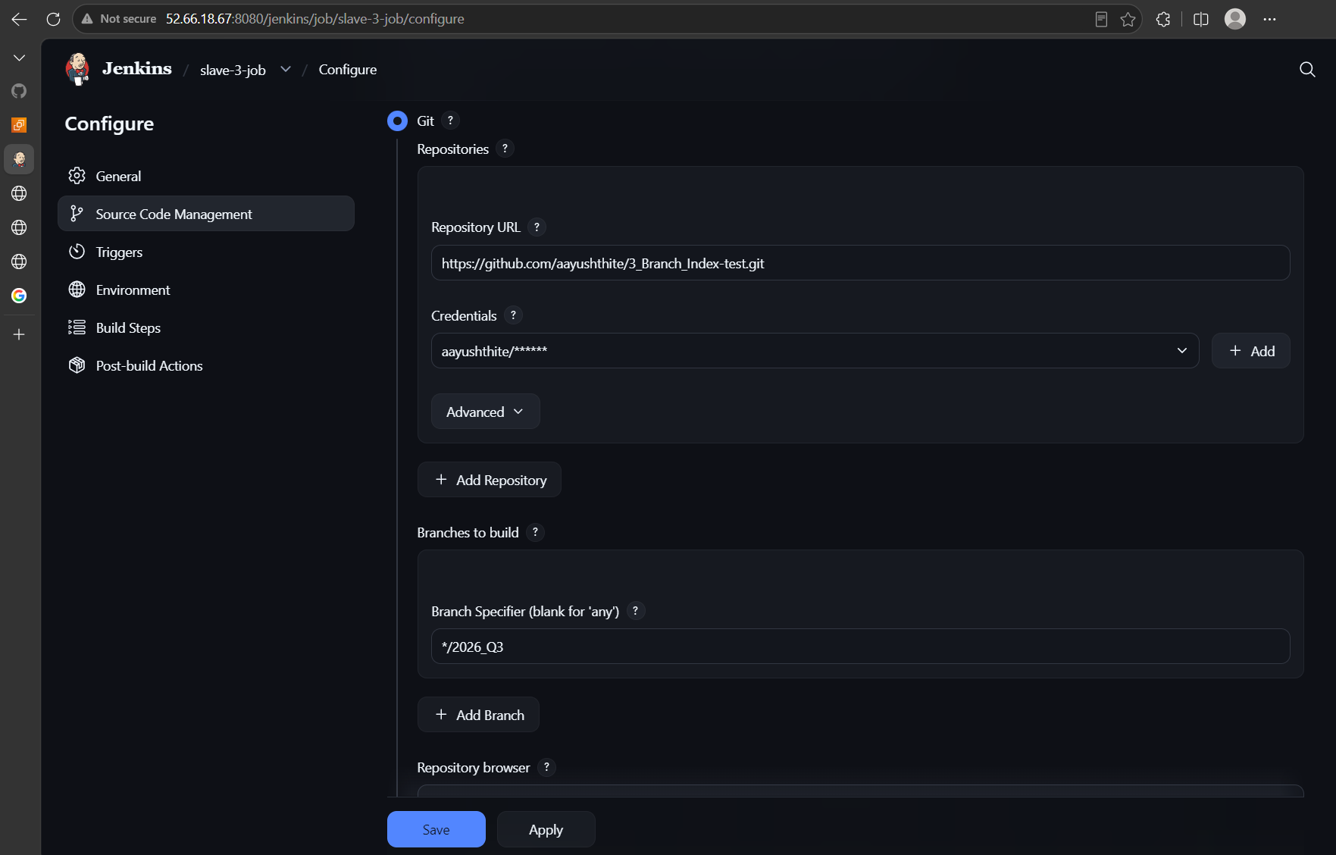
Deployed 2026_Q3 branch on slave-3
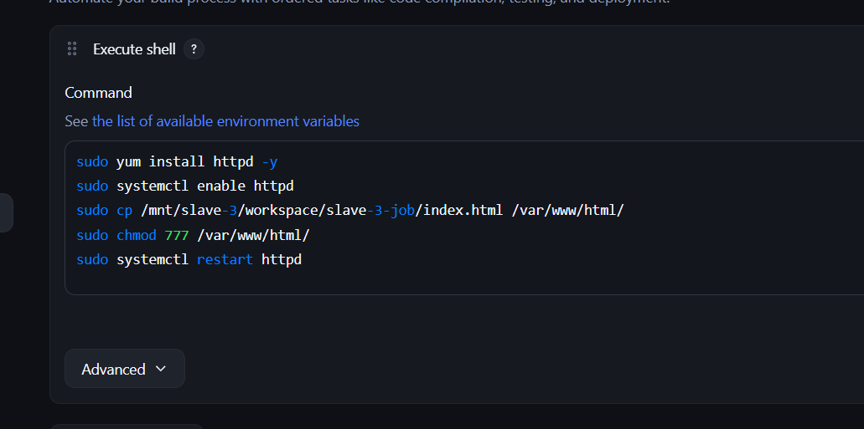
Slave-3-job successful

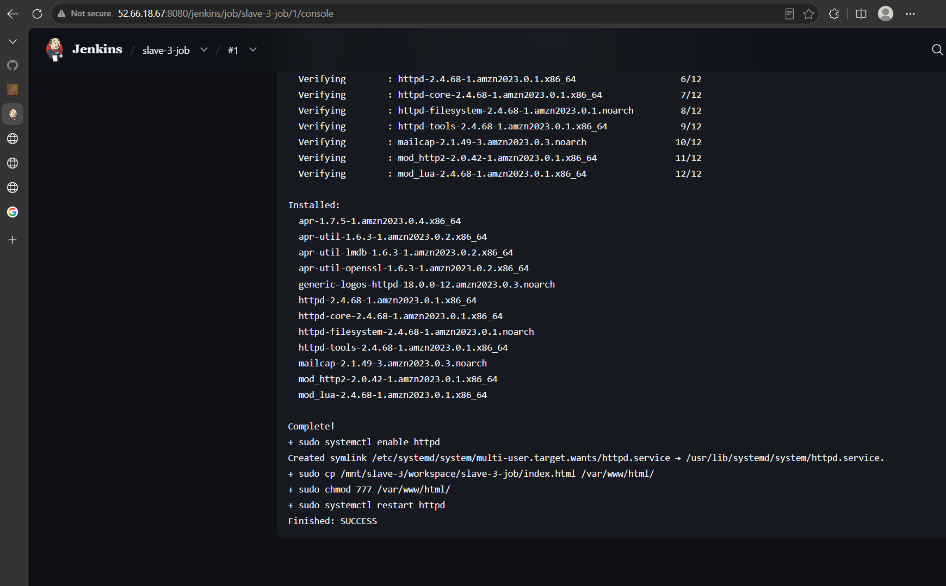

Q3 branch index.html accessible from browser
